Appendix B: Selected sample applications

1. *Levenshtein* Edit-Distance Calculator
   1. Description of Existing Application

This system allows user to enter two word into client console, which then requests a server to compute the *Levenshtein Distance*, LD, between the two words, where LD is the minimum number of single-character edits (insertion, deletion, substitution) required to change one word into the other. For example, the LD between "kitten" and "sitting" is 3, since the following three edits change one into the other, and there is no way to do it with fewer than three edits:

* **k**itten → **s**itten (substitution of "s" for "k")
* sitt**e**n → sitt**i**n (substitution of "i" for "e")
* sittin → sittin**g** (insertion of "g" at the end)
  1. Current Design

Figure 1 shows an overview of the current architecture for this system. It only contains three classes, Client, calculator, and Message. Both the Client and calculator run as separate processes, and maybe even on separate machines. The Client allows the users to type in two words using a simple console interface. Then, it creates an instance of Message class containing these two words and sends it to the calculator. The calculator computes the LD, package that result up in a new instance of Message, and send it back to Client. The UML Sequence Diagram in Figure 2 shows this interaction.

Note, that the interaction is asynchronous from the Client’s perspective. In other words, the Client does not block while waiting for a response to the translation request.

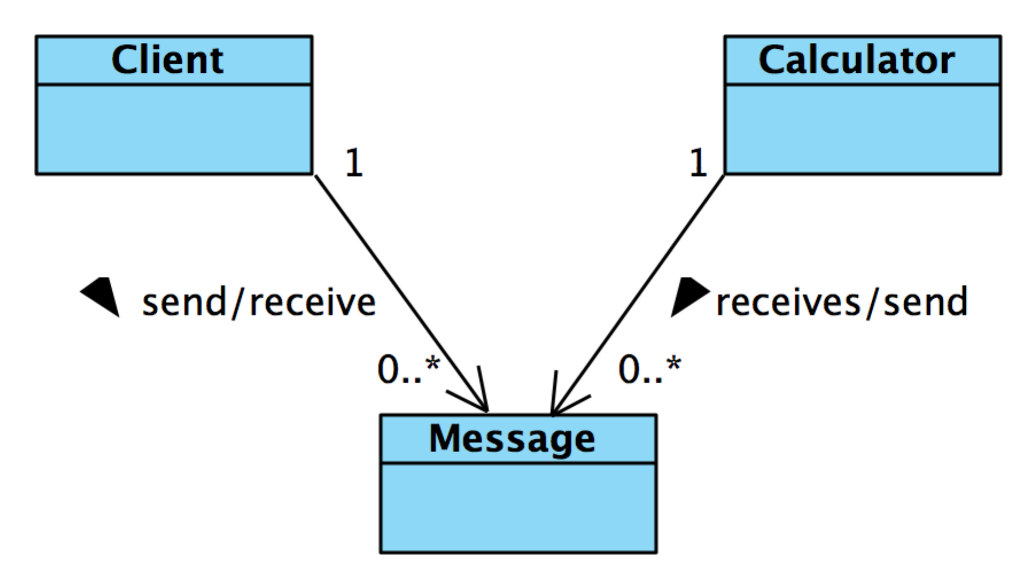

Figure 1: Architecture diagram of Levenshtein Edit-Distance Calculator

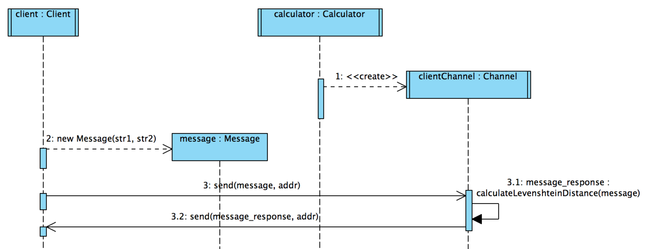

Figure 2: Interaction diagram between Client and Edit-Distance Calculator